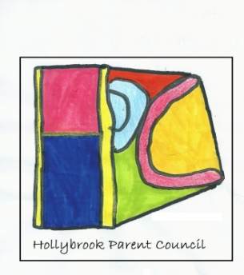
Parent Council Meeting
Thursday 16nd March 2023
People present: Elaine Masterson(Zach)/ /Susan Gordon (Kelsey), Christina Rpobertson ( Caleb and Jason) Allison MacLeod ( Acting HT), Craig Milne ( DHT)
Apologies: Sahridela Hasan (Areen)
Minutes of previous meeting | Action
Welcome and any new members | Gillian Vance joined this time.
Matters Arising:  Roles discussed and possibly identified:  - Chair (To chair meetings and guide the PC to achieve its aims))  - Treasurer (to keep a good record of all money related matters)  - Secretary (to handle communications, minutes?) | Discussed the different roles of the parent council.  - Gillian happy to be the chair and all agreed. Gillina will set agenda and chair the meetings.  - Susan happy to be the treasurer and liaise with Margaqret from the office re money transactions.  - Gillian and Elaine to work together re communications ( secretary role).  - Christina happy to be vice chair.  All chatted about helping each other as new to everyone.
Communication: Whats app group and or Facebook group discussed | - GV will set up Hollybrook P.T.A G-Mail & Facebook Accounts for members.  - EM Will set up a What’s App Group
School loss and remembrance ideas/ updates. | - CM Has been Awarded a grant for outdoor’s.  - Garden space possibly bench where pupils can go and read, plaque  - Scan code/ member of staff will help pupil’s leave message of a memory they have.
PC Identity: Hoodies, T-shirt, cap? | - Parent Council Landyards  - Badges with their picture or visitors badges with the strong logo (Jacks)
Events this term | - Coffee morning – set up table selling books that have been donated to the school via staff n parents.  - Uniform swap facility .  - Disco  - Discussed parent groups in school. ( eg of finance advice and possibly Govan law centre to parents night.
Dates and regularity of meetings? | - Every six weeks if needed.  - PVG needed?  - Next meeting 25th April @1.30pm
Transport Changes | - AM Discussed letter detailing transport changes which will be implemented Aug this year starting with new S1 Pupils. May eventually effect others G.C.C may contact parents at a later date .  - Struggling getting Escorts for pupils
Email address link to council for Audit of accounts and check down load of budget.

Parent / clubs resources: emails ( Sense, GDA)

