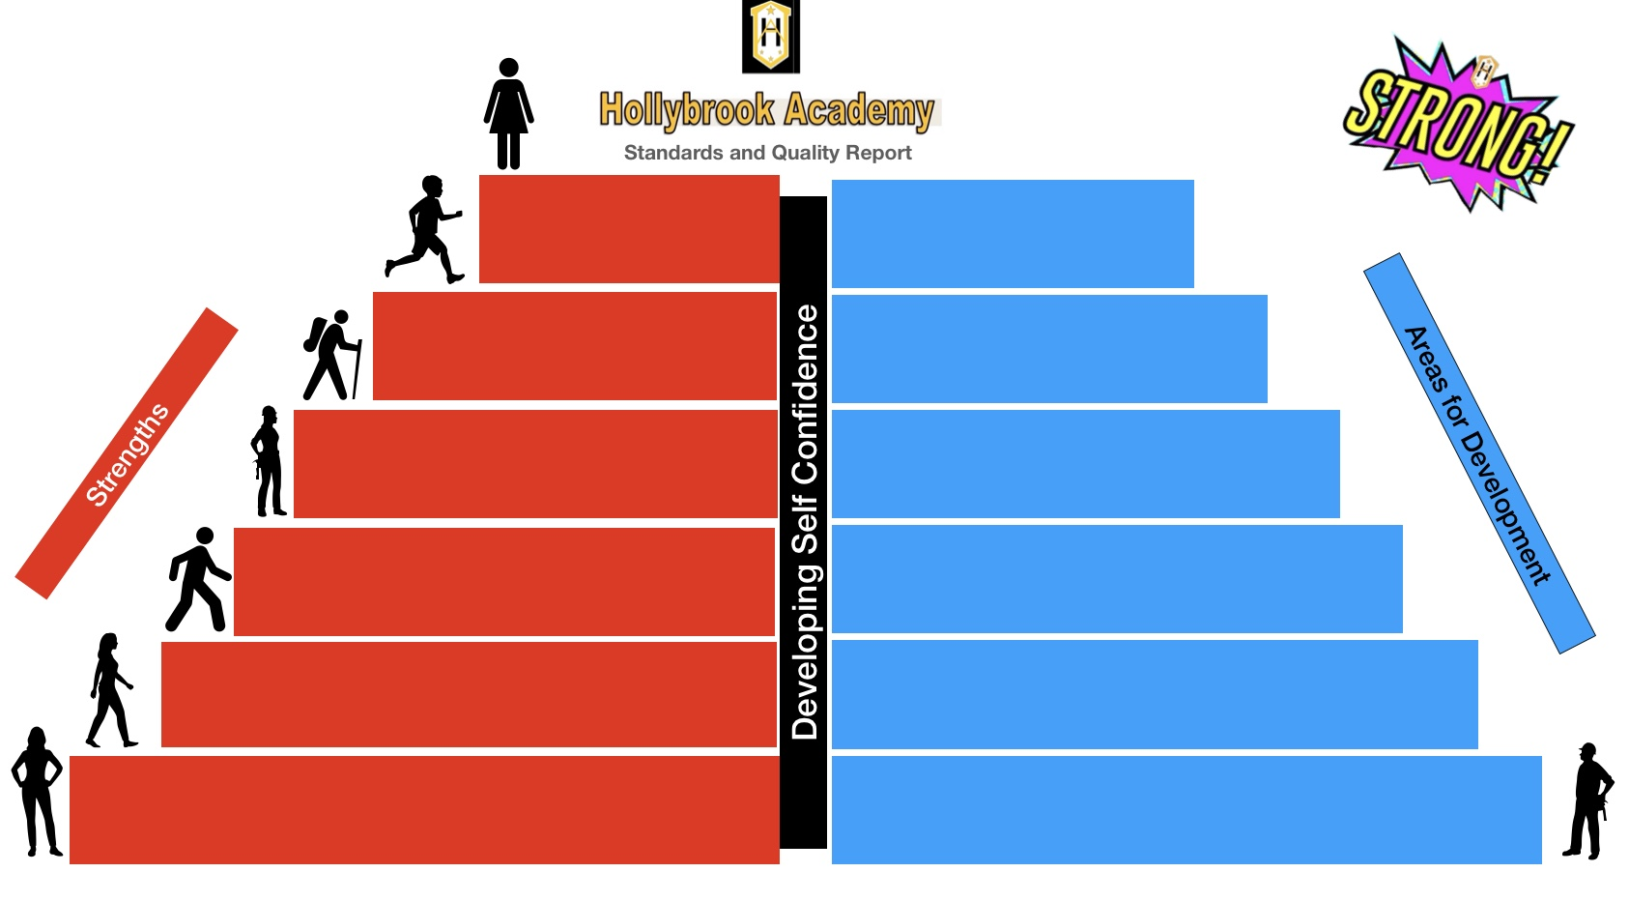

Individual PSE and curricular progrogrammes in place for pupils needing specific and targeted support.

There are opportunities at all stages and throughout the year to understand the importance of health and wellbeing. This includes outdoor learning embedded in curriculum; a focus on health eating and mental wellbeing.

All pupils have access to iPad through Glasgow’s Connected Learning Programme.

Greater parents and carers views to continue to share learning via online digital platforms.

Nurture underpins all learning and teaching.

100% of pupils given the support and opportunities to move to positive post school destination.

All S4-6 pupils have attainment with breadth and depth from National 1 to National 5.

Targeted Health and Wellbeing being groups across the school for *all.* These includes a whole school weekly health and wellbeing afternoon.

Further enhance digital learning programme and improve connectivity for all pupils, teachers, SfLWs and parents and carers.

Complete the whole school Language and Communication Award.

Continued development of new curriculum map.

Further develop partnerships

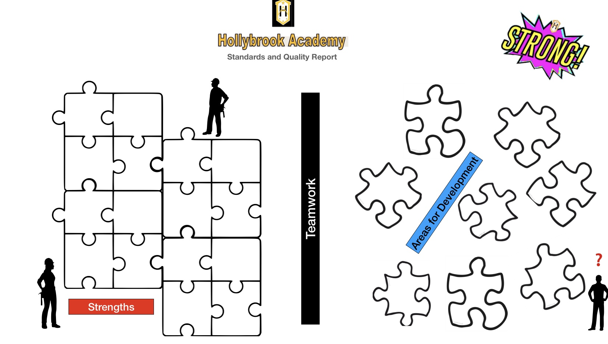

Leadership sit on different on Joint Support Team & developing SIM.

Budgets are devolved to faculties, pupil council, parent council and SfLWs.

More opportunities post lockdown for team teaching

Develop partnerships with local schools Kings Park and Middlefield to share resources.

More effective use of our outdoor resources

Links to local schools to ensure rigorous moderation and SQA verification.

Ongoing work with Primary colleagues to support P7 transitions.

All staff supported pastoral care and connected with families through lockdowns.

Weekly Pastoral Support Meetings to meet learner needs.

Working groups in place to drive new initiatives forward to support learners.

Pupils support networks in place through lockdown.

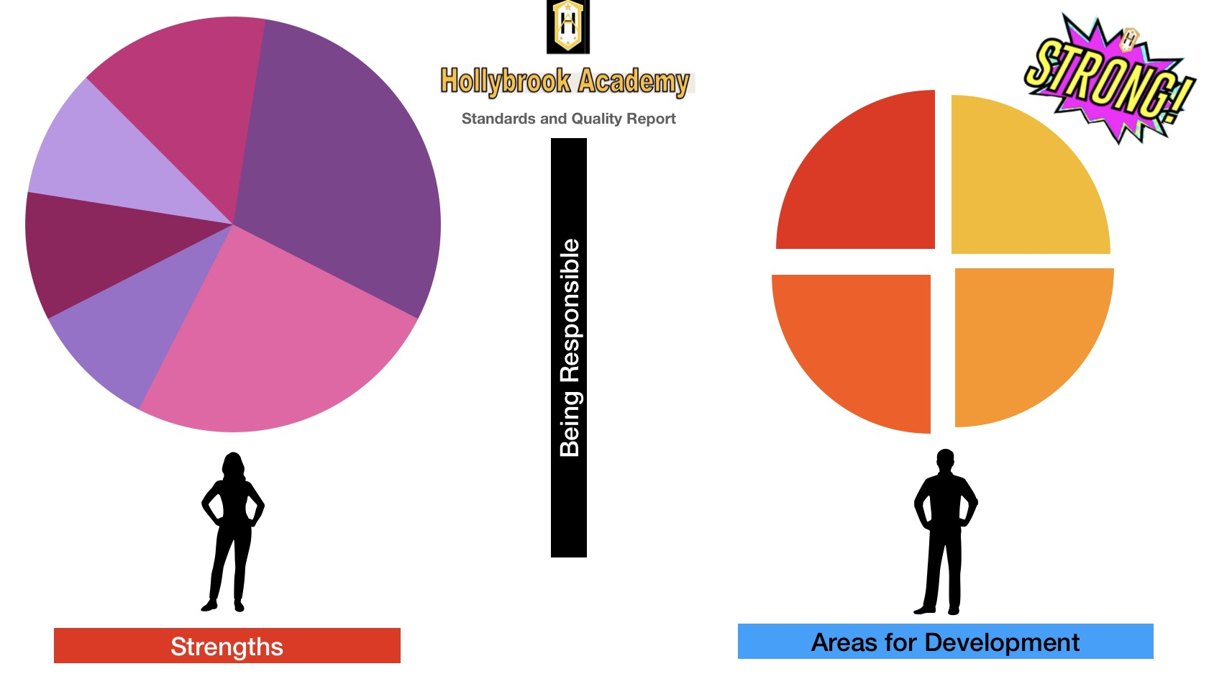

Pupils have support to be safe and responsible online, including targeted support.

Development of school allotment to support understanding of sustainability.

Weekly sessions with local Community Police and On the Edge Programme to support learners understanding what they can do to stay safe, both in community and online.

Expand our online safety for pupils, parents, carers and staff.

Initiated a partnership with Castlemilk Youth Complex to give pupils increased opportunities for support and a greater breadth of experiences.

Working group in place to promote and re-establish the school’s Vision, Values and Aims: STRONG .

Further develop links and opportunities with Castlemilk Youth Complex.

Working group established to further support and develop understanding of how to live sustainably.

This session’s planning has responded to the needs of pupils who have lived through lockdowns.

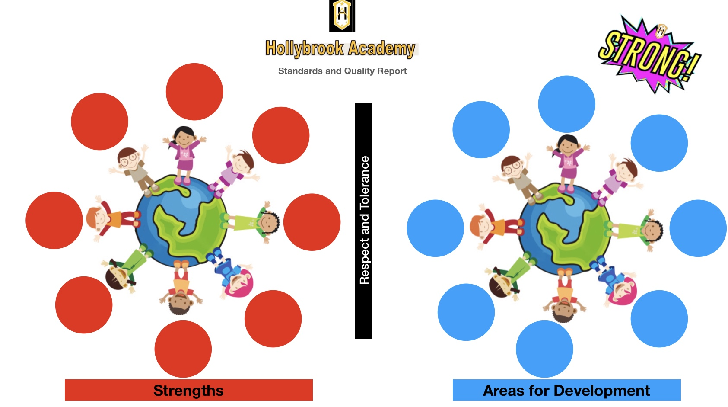

Pupil GIRFEC and wellbeing surveys and planning.

Sustainability a key driver in decision making.

Part of Glasgow’s Youth Forum,

Pupils consulted to ensure they are in a pastoral support class that meets their needs.

Working towards LGBT Charter & support group

Pupils provided with opportunities to support each through clubs and H&S others through clubs abnd

LGBT group to expand and complete the LGBT Charter.

Active role for all staff and pupils in recognizing COP26 and its impact.

New Equalities handbook being developed.

School has links to charities and ongoing events to support them: MacMillan, Mary’s Meals, Children in Need and Youth Phipantopy Award.

Pupils have access to support base at all times for additional help and reflection.

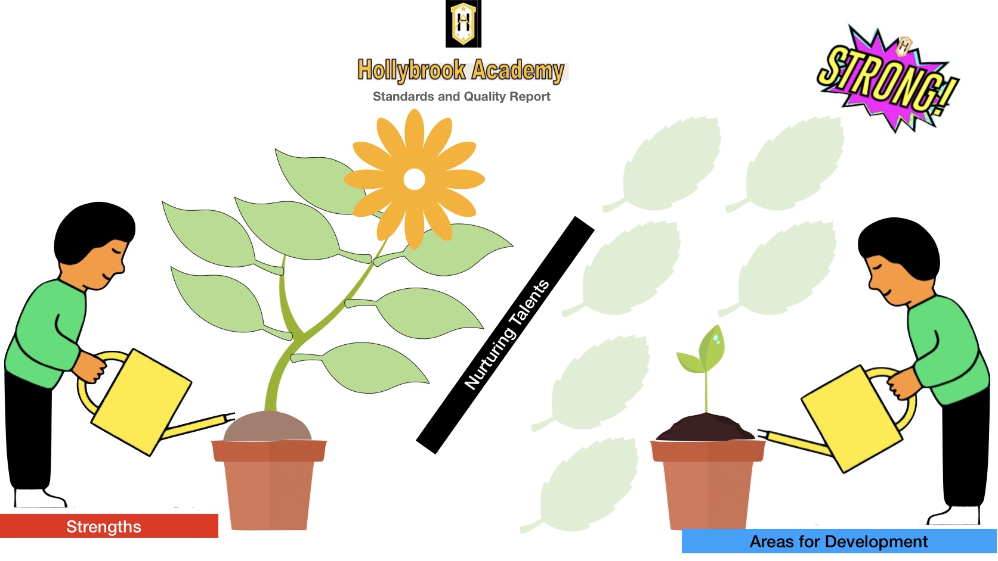e

New reading scheme established in English.

Increased staff training to support Emotion Works .

Continue to develop staff skills and confidence through observations and team teaching.

Pupils have access to school counsellor from Castlemilk Stress Centre. Centre.

Daily tutor time with weekly programmes.

Specialist Music therapy two days a week.

All staff, including SfLWs have planned and ongoing Continuous Professional Development.

Pupils achievements celebrated in school and on social media.

New space created for the nurture class.

Re-establish extracurricular clubs after COVID lockdown

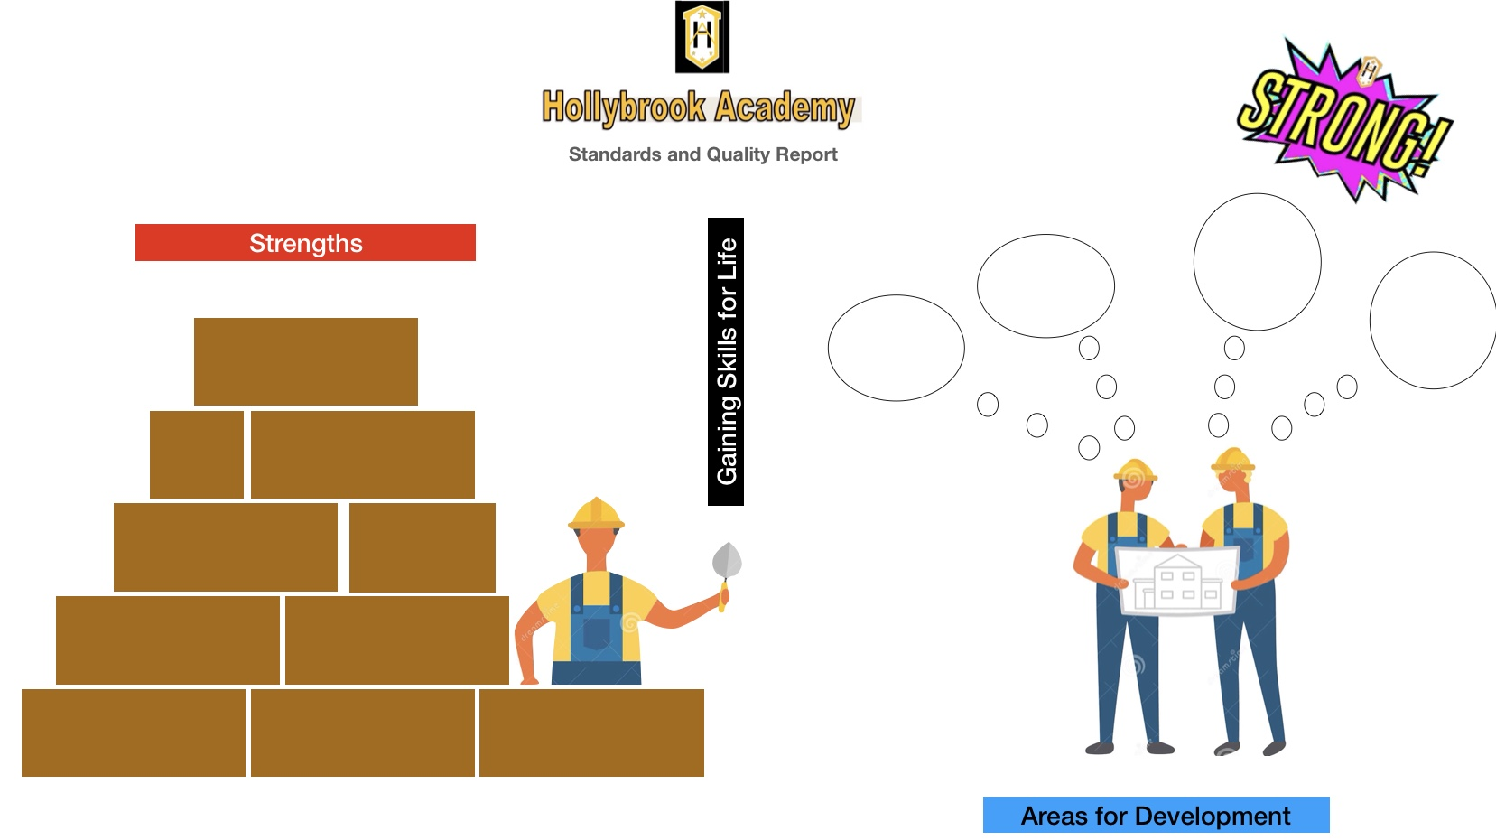

Themed business, industry and employment events built into annual planning and targeting all pupils.

New Developing Young Workforce member of staff to support with transitions.

Increase volunteering opportunities.

Skills Development Scotland in school one day a week to support transitions.

Re-establish work placements and shadowing post COVID.

Ongoing partnerships with colleges with lecturers coming into school and senior pupils attending college part-time.

Staff and pupil consultation resulted in new curriculum map and times to the day to reduce transitions.

Forward planning in all curricular areas and at all stages have a focus on skills.

Sensory room in pace and timetabled for pupils who need sensory support.

Develop new senior phase Skills Class.