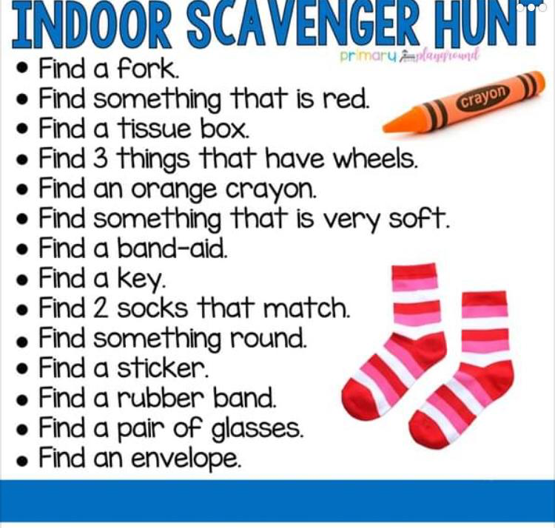
- Hollybrook Indoor Scavenger Hunt (Week 1)

